Name _________________________________ Date _________________
Day 4: Circles Review 7 Regulars

1) The radius of a circle is 17.5 cm. What is the length of the diameter?

2) The diameter of a circle is 14 meters. What is the length of the radius?

3) You want to find the distance around a circle, what formula would you use?

A r = d ÷ 2 B C = 2πr C d = 2r D A = πr²

4) You want to find the amount of space that fits inside a circle, what formula would you use?

A r = d ÷ 2 B C = 2πr C d = 2r D A = πr²

5) The diameter of a circle is 20 inches. Find the circumference of the circle.
Leave your answer in terms of π. Show your work.

6) Find the area of a circle whose diameter is 10 cm. Leave your answer in terms of π.
Show your work.

7) The diameter of a circle is 24 inches, what is the circumference? Round your answer to the nearest tenth. Show your work.

8) The diameter a circle is 12 centimeters. What is the area? Use 3.14 for π.
Show your work.

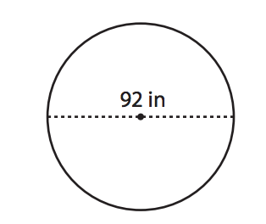
9) Find the radius and diameter of the circles in the following diagrams.

Radius: ____________________

Diameter: _____________________

10) The radius of a circle is 8 meters. Find the circumference of the circle. Use 3.14 for π.
Show your work.

11) Find the radius and diameter of the circles in the following diagrams.
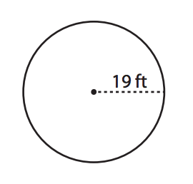

Radius: ____________________

Diameter: _____________________

12) The radius of a circle is 11 meters. Find the area of the circle. Round your answer to the nearest hundredth. Show your work.

